Continuity of Education Plan Framework
Companion Document
Before Writing a Plan – Consider these guiding questions.
- Who is involved in making a continuity of education plan for the LEA?
- What are the LEA priorities/goals in providing continuity of education?
- Are there enrichment and review priorities?
- Are there planned instruction priorities?
- How will the LEA deliver continuity of education enrichment and review opportunities?
- How will the LEA deliver planned instruction?
- How will the LEA assess planned instruction?
- How will the LEA meet the access and learning needs of all students?
Definition of Terms
- Continuity of Education: Continuity of Education is the overall term for any educational practices that occur in the event of a prolonged school closure. It is important that students have the opportunity to maintain and develop skills while away from the customary school environment. This can be done through Planned Instruction or Enrichment and Review.
- Planned Instruction: Planned Instruction is formal teaching and learning similar to that which occurs in a classroom setting. Within this process, teachers use planned courses of instruction of new concepts/skills aligned to grade level standards. Teachers assess the learning of their students and make adjustments to instruction based upon student progress. In order to receive grade and credit, students must attend regularly and complete the course requirements.
- Enrichment and Review: Enrichment and Review consists of informal activities to reinforce or extend students’ prior learning. No standards and skills are addressed through Enrichment and Review.

Decision Tree
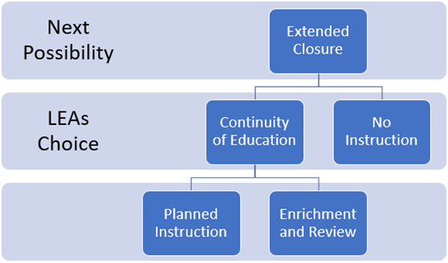
Writing a Plan – Consider including the following information in each section.
Goal of the Plan
- Provide the overall goal and priorities for continuity of education in 1-2 sentences.
Overview of the Plan
- Summarize how the plan is aligned to the LEA’s mission and vision while offering clarity and purpose to what is outlined in the plan that follows.
Expectations for Teaching and Learning
- Provide a general overview of the prioritized grade and course level content that will be enriched and reviewed. Provide a general overview of the prioritized grade and course level content that will be moving forward with planned instruction, if any. Provide a rationale.
Communication Tools and Strategies
- Share what parents, students, and community can expect regarding communication. Where can they go for information? What tools and resources are provided? Is there planned delivery or scheduled times for communication to be sent/released? Should parents be using particular applications or media for regular updates?
Access
- Provide instructions on where students can access enrichment and review opportunities. Provide instructions on where planned instruction will be delivered, if it is occurring. Provide alternative access options for students who have barriers to technology devices or internet connectivity.
Staff General Expectations
- Outline the expectations of teachers and staff related to posting or hosting educational opportunities and/or planned instruction; parent communications; and work time availability. Considerations for both daily and weekly staff expectations can be included.
Student Expectations
- Outline the expectations of students for participation in educational opportunities and/or the completion of assignments. Establish the meaning of expectations related to student engagement, participation, and completion of assignments.
Attendance and Accountability
- Outline the expectations for distance education attendance. Is this synchronous attendance, or asynchronous participation? What demonstrates meaningful participation?
- Outline the procedures and practices that will be in place for accountability. This can be universal or course/grade specific, but should be consistent for all students in that particular course or grade. State what accountability practices will be in place for grading and credit earning, if any.
Good Faith Efforts for Access and Equity for All Students
- Communicate in what ways reasonable and appropriate supports are in place to demonstrate a good faith effort of meeting the needs of all learners.
Special Education Supports
- Communicate in what ways reasonable and appropriate supports are in place to demonstrate a good faith effort in meeting the needs of students with individualized education plans.
- Provide specific instructions for parents who have questions or concerns.

English Language Learner Supports
- Communicate in what ways reasonable and appropriate supports are in place to demonstrate a good faith effort of supporting the language proficiency needs of English learners.
- Provide specific instructions for parents who have questions or concerns.
Gifted Education
- Communicate in what ways reasonable and appropriate supports are in place to demonstrate a good faith effort of providing gifted education programs and services.
- Provide specific instructions for parents who have questions or concerns.
Building/Grade Level Contacts
- Share the points of contact for each school building that would take the lead in building-specific communication efforts and provide answers to specific inquiries from students and parents.
Resource Links
- Provide a list of resources, tools, and/or applications that will be used to support the continuity of education plan described above. Which resources will be provided for enrichment and review? Which resources will be utilized for planned instruction?

